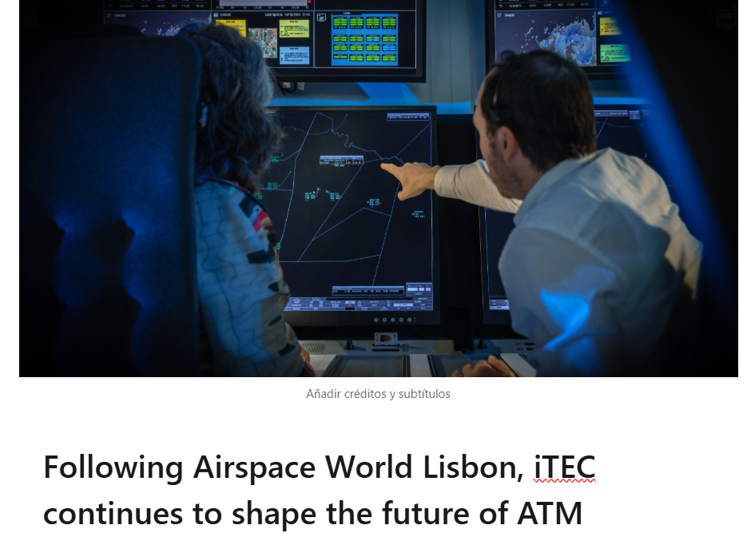
Driving the Next Generation of ATM Through ARTEMISA, Innovation and Leadership
The iTEC community arrived at Airspace World by CANSO in Lisbon with a clear message: the future of Air Traffic Management is no longer a distant vision, it is already being shaped through collaboration, innovation and strategic transformation. The event marked a major milestone for iTEC, reinforcing its role at the centre of Europe’s next-generation ATM evolution, strongly aligned with the SESAR programme.
One of the key moments was the meeting between iTEC Director Marcel Bakker and Benoit Fonck , Chief of SESAR Joint Undertaking Programme, highlighting a shared commitment to modernising ATM through closer collaboration, innovation and faster delivery models.
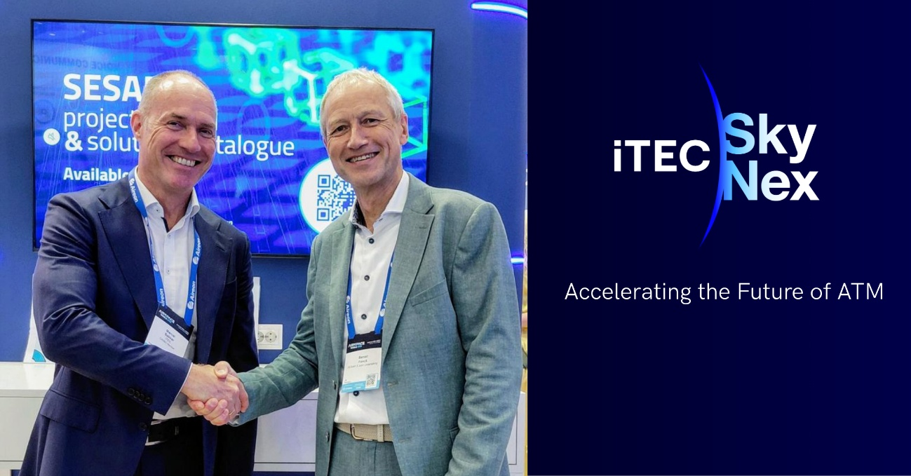
This is a crucial moment for the industry. As ATM moves toward cloud-native, service-oriented and data-driven architectures under SDO 8 (Service-oriented delivery model (data driven and cloud based), iTEC is evolving beyond a technology collaboration into a platform driving large-scale operational modernisation.
A New Leadership Structure for a New Transformation Cycle
To support this acceleration phase, iTEC is reinforcing its organisational structure with three strategic leadership appointments designed to connect portfolio strategy, innovation and programme execution.

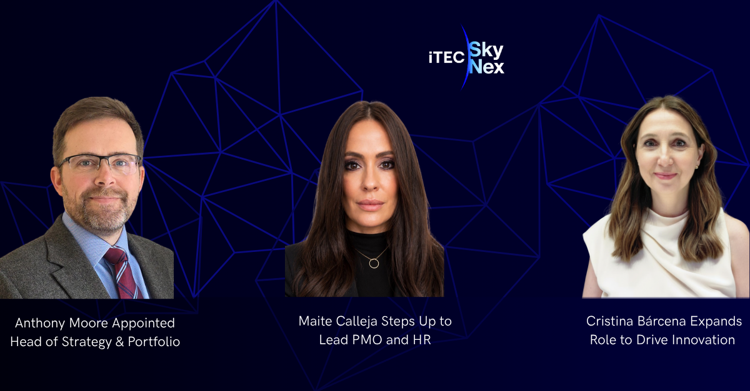
Anthony Moore has been appointed as the new Head of Strategy & Portfolio, bringing extensive operational and leadership expertise from his 17-year career in the Royal Air Force (RAF) and his experience across international ATM environments. His appointment strengthens iTEC’s long-term strategic vision and portfolio governance as the collaboration moves into a new development phase.
At the same time, Maite Calleja has expanded her responsibilities by combining her PMO Manager role with Human Resources leadership. This evolution reflects the growing complexity of the multi-partner iTEC environment and aims to reinforce coordination between governance, programme execution, communication and people management. Her role will also be instrumental in driving ARTEMISA communication and dissemination activities aligned with SESAR priorities.
In parallel, Cristina Bárcena has assumed an enhanced role as iTEC Evaluation and Innovation Manager, leading evaluation, prototyping and innovation activities while ensuring strong integration with SESAR initiatives. Her work will help accelerate operational validation, technical demonstrations and innovation checkpoints essential for future ATM deployments.
Together, these appointments represent more than organisational changes. They form a coordinated leadership model designed to support the acceleration of iTEC’s evolution toward the next generation of ATM services, combining strategy, operational delivery and innovation under a unified transformation vision.
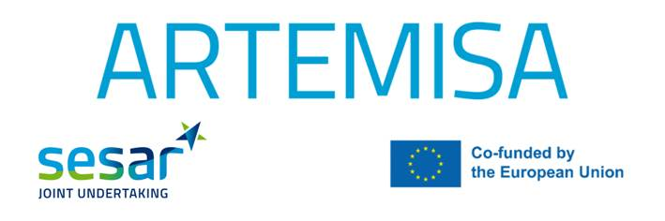
ARTEMISA Recruitment: Building the Expertise Behind the Transformation
ARTEMISA, an industrial research project under SESAR Joint Undertaking , officially awarded full funding as part of the iTEC SESAR ARTEMISA initiative (WA3 1: New Generation ATS Platforms for En Route and TMA Operations), aimed at enhancing operational efficiency and delivering advanced capabilities within the ITEC framework.
Supporting this strategic shift, the recruitment process for SESAR ARTEMISA Experts has now been successfully completed. A total of 3.5 Full-Time Equivalent positions have been allocated across participating ANSPs, including NATS, NAV CANADA, Polish Air Navigation Services Agency and ORO NAVIGACIJA, ensuring the integration of highly qualified expertise across the collaboration.
These experts will play a critical role in supporting SESAR-related iTEC developments, while also contributing directly to evaluation activities, operational preparation and innovation initiatives. Their planned incorporation from September represents another concrete step in strengthening the delivery capacity required for future ATM modernisation.
The timing is highly significant. As SDO 8 drives the industry toward interoperable cloud-based ATM ecosystems, iTEC’s roadmap between 2026 and 2035 is expected to undergo substantial transformation, including the refactoring of Level 2 services and the adoption of more flexible, scalable architectures.
From Vision to Execution: Defining Cycle 2
Beyond leadership and recruitment, iTEC continues advancing the Definition of Cycle 2, the phase where the scope of the second development cycle is being established through the identification and prioritisation of Change Proposals (CPs).
This dynamic process ensures that future developments remain aligned with programme objectives while maintaining realistic implementation boundaries. It also reflects the broader transformation underway across European ATM: faster adaptation cycles, stronger interoperability requirements and closer integration between operational needs and technological innovation
A Defining Moment for the iTEC Community
Airspace World 2026 in Lisbon confirmed that iTEC is entering a new phase. With stronger SESAR alignment, reinforced governance, expanded innovation and targeted ARTEMISA recruitment, the collaboration is strengthening the foundations for faster ATM modernisation across Europe and beyond.
The focus is clear: enabling next-generation service-based ATM solutions and transforming how large-scale international ATM programmes are delivered and evolved.

